PRAYER OF THE FAITHFUL

- Mary, the Mother of God -

- World Day of Prayer for Peace -

January 1, 2025

PRAYER OF THE FAITHFUL
Mary, the Mother of God - World Day of Prayer for Peace - January 1

Priest: On this Solemnity of Mary, the Mother of God,
we begin a new year and the Jubilee Year of Hope,
and Catholics throughout the world
are invited to pray for peace.
Therefore, let us implore God’s blessing upon our world
through the intercession of the Blessed Virgin Mary,
and pray for needs of this new time
of challenge and grace.

1.
Priest: At the beginning of this New Year,
let us light the first candle for peace, tolerance and respect.

The first person lights a candle at the altar.

Reader 1: Let us pray for peace and mercy
that comes from a tolerance and unity
that respects diversity
and enhances the well-being of all the inhabitants
of the world and our country,
especially for the people of Ukraine and the Holy Land..

Reader 2: Let us pray that all members of society
will support truth, goodness and justice,
where it will be easier to live God’s law,
where joy and hope will be the lot of many,
where all children will be surrounded with love,
where prejudice will have no place,
and where God’s mercy will be more evident to all.
Come, Lord, and grant us peace.
All sing:

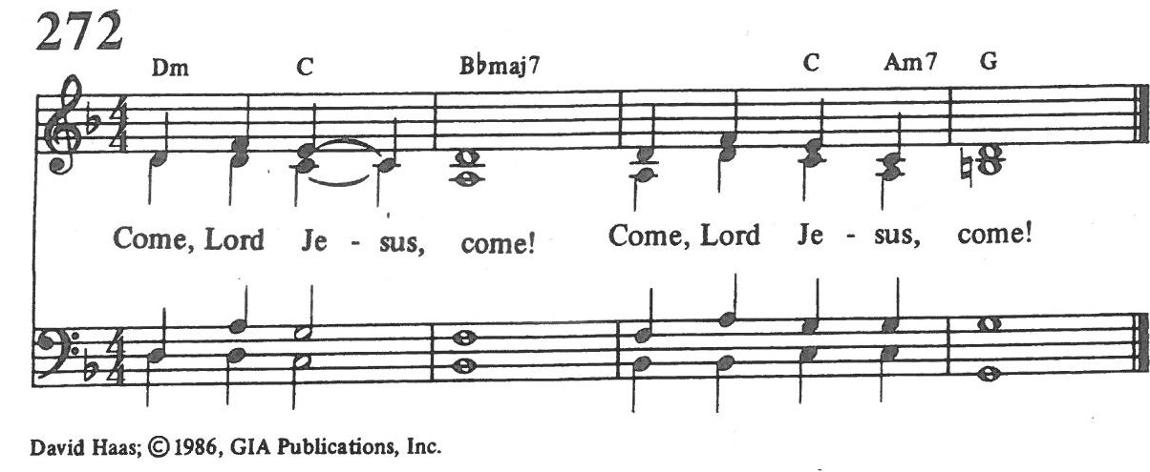
2.
Priest: In this New Year of grace let us light the second candle
for peace, justice and generosity.
The second person lights a candle at the altar.
Reader 1: Let us pray for peace and hope
that comes from the eradication of poverty and want
everywhere in Canada and the world,
but especially among children and the First Nations.

Reader 2: Let us pray for a just sharing of the bounty of this earth,
for solidarity between the peoples of the Americas,
and for those who are marginalized,
–that we may be merciful and kind in sharing our talents and resources,
leading all people to creative, holy and satisfying lives.
Come, Lord, and grant us peace.
All sing: Come, Lord Jesus, Come!

3.
Priest: Seeking the intercessions of the Blessed Virgin Mary,
let us light the third candle for peace, forgiveness and harmony.

The third person lights a candle at the altar.

Reader 1: Let us pray for peace throughout the world
that comes from the resolution of all disputes,
for all peace-keepers and aid workers,
for all victims of terrorism who have died this year,
for the weak and defenceless,
and for immigrants and refugees,
-that they may know mercy
and be welcomed to take their rightful place within society.

Reader 2: Let us pray for justice, harmony and forgiveness among all people,
that ancient hurts will be forgiven,
-that mercy and reconciliation may reign over all the world,
and that we may find lasting solutions to poverty, terrorism and crime.
Come, Lord, and grant us peace.
All sing: Come, Lord Jesus, Come!
4.
Priest: In the spirit of mercy and reconciliation,
let us light the fourth candle for peace, love and goodness.
The fourth person lights a candle at the altar.
Reader 1: Let us pray for peace that comes from a greater understanding and love
between Christians, Muslims, and Jews,
and for solidarity among all people of good will,
-that our mercy, love and compassion may promote harmony
and tolerance among all people in the ways of justice and peace.

Reader 2: Let us pray for those whose lives give birth to evil
and who pervert the truth and turn to violence,
especially in the name of God and religion,
and for those who, as a result,
now doubt the power of faith, love and goodness,
for those lost in grief,
and for all who have been robbed of hope or security.
Come, Lord, and grant us peace.
All sing: Come, Lord Jesus, Come!
5.
Priest: Believing in the promises and infinite mercy of God,
let us light this fifth candle for peace, dignity and holiness.
The fifth person lights a candle at the altar.
Reader 1: Let us pray for peace that flows from a clearer sense
of the dignity and value of each human person
and the sanctity of marriage, the unborn and the family.
Let us lift in prayer all our young people,
that they may find solid mentors in the faith,
leading them to creative, holy and satisfying lives.

Reader 2: Let us pray for all scientists, technicians, and health professionals,
that respect for life be foremost in their endeavours
to bring the best of science to the care they exercise,
and that their work will be profitable for all segments of society
and for the good of the whole planet.
Come, Lord, and grant us peace.
All sing: Come, Lord Jesus, Come!
6.
Priest: On this Solemnity of Mary,
let us light the sixth candle for peace, virtue and truth.
The sixth person lights a candle at the altar.
Reader 1: Let us implore the intercession of Mary and pray for mercy and peace
that flows from a society where it will be easier to live virtuously,
where young people will be taught by word and deed
the ways of virtue and truth.
Let us seek her guidance for all religious leaders,
that they may always preach what is true and good
and live accordingly.

Reader 2: Let us pray for our government leaders
that they may have the courage and wisdom always to decide
what is best for the common good,
according to God’s plan of salvation.
Come, Lord, and grant us peace.
All sing: Come, Lord Jesus, Come!

7.
Priest: Invoking the intercessions of Mary and the Communion of Saints,
let us light the seventh candle for peace, faith and hope.
The seventh person lights a candle at the altar.

Reader 1: Let us pray for peace through all who are engaged in works of mercy,
that it may lead them to a deeper spiritual peace
and bring God’s mercy to all in spiritual or physical need;
for an environment in society that respects religious values and beliefs,
for the health and spiritual well-being of the clergy and all religious,
and for a generous response to God’s call
in the lives of all people, especially young adults.

Reader 2: Let us pray for the renewal of our parish and families,
for the sick and dying; and for all Christians,
that during this Holy Year of Hope
we will open our hearts in mercy to all God’s people
and to the message of salvation.
Come, Lord, and grant us peace.
All sing: Come, Lord Jesus, Come!
8.
Priest: As we ponder God’s mercy and deeds of salvation let us light the eighth candle for peace, spiritual renewal and new life for all parishioners.

The eighth person lights a candle at the altar.

Reader 1: Let us pray for the spiritual peace and physical well-being
of all the members of our Parish and their families;
for God’s blessing upon each one and all,
that we may have a joy and life-filled, peaceful New Year,
taking up the challenge of living the Christian Faith
to show God’s loving mercy in witness to Jesus’ gift of salvation.

Reader 2: Let us pray for those who have died this past year, especially:
all members of our parish and family,
all soldiers killed in battle;
all victims of terrorism ;
those who gave their lives in acts of heroism;
that they may behold God face to face and know his mercy
and the peace of His Kingdom.
Come, Lord, and grant us peace.
All sing: Come, Lord Jesus, Come!

The presiding priest concludes the intercessory prayer:
Most high God,
the pregnancy of the Blessed Virgin Mary
symbolizes the hopes and expectations
of the human race.
On the eve [first day] of this new year,
we implore your inspiration and guidance
that all we do may find its beginning in you
and reach completion
through your Son, Jesus Christ, our Lord,
who lives and reigns for ever and ever.

